Villach (AT) 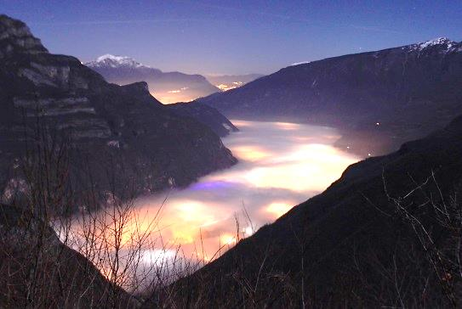 | Conference  “The decline of rural areas? Demographic changes in the Alps – presentation of the Fifth Report on the State of the Alps”  Villach (AT) 30 November – 1 December 2015

Day 1
November, 30 | 13:30 - 19:00
13:30 – 14:15 | Welcome  Markus Reiterer – Secretary general of the Alpine Convention  Gaby Schaunig – Vice Governor of Carinthia  Ewald Galle – Austrian Delegation to the Alpine Convention  Sara Vito*– Region Friuli - Venezia Giulia  Representative for Slovenia*
14:15 – 14:45 | Presentation of the RSA 5 results for the Alpine Area  Marianna Elmi, Permanent Secretariat of the Alpine Convention
14:45 – 15:05 | Demographic development in the Austrian Alps, with a special focus on Carinthia  Peter A. Rumpolt, Statistik Austria
15:05 – 13:15 | Questions and Discussion
15:15 – 15:35 | Demographic development in the Italian Alps, with a focus on the Friuli-Venezia Giulia region  Mauro Albani, ISTAT
15:35 – 15:45 | Questions and Discussion
15:45 – 16:15 | Coffee break
16:15 – 16:35 | Demographic development in the Slovenian mountain areas  Tomaž Miklavčič, Slovenian Ministry for Environment and Spatial Planning
16:35 – 16:45 | Questions and Discussion
16:45 – 17:30 | Summary and Preview of the round tables for day 2  Ewald Galle
From 19:00 | Common Dinner at Parkhotel Villach (Großer Bambergsaal)

Day 2
December 1 | 9:00 – 12:30
Parallel discussions
Round table 1  New inhabitants in the Alps | Moderation: Simona Vrevc – Permanent Secretariat of the Alpine Convention  Input presentation:  Andreas Haller – Institute for Interdisciplinary Mountain Research of the Austrian Academy of Sciences
Round table 2  Labour market and job opportunities in the Alps | Moderation: Elke Beneke – EB Project Management  Input presentations:  Francesco Anesi – EURAC (Institute for Regional Development and Location Management)  Miro Kristan – Soča Valley Development Centre
Round table 3  Public services for the population in the Alps: priorities | Moderation: Marianna Elmi – Permanent Secretariat of the Alpine Convention  Input presentations:  Barbara Černič-Mali – Urban Planning Institute of the Republic of Slovenia  Marcello Petitta – ENEA Italy
11:00 – 11:30 | Coffee break
11:30 – 12:30 | Report from the round tables and Conclusions
From 12:30 | Standing Lunch

For day 1, an interpretation service from and into German, Slovenian and Italian will be provided. The working language for the round tables on day 2 will be English.

